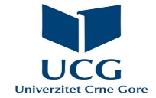
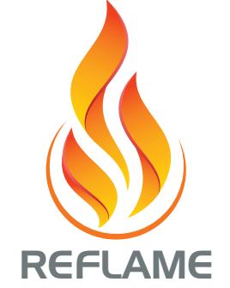
Summer school
Faculty of Philology, University of Montenegro
REFLAME YOUR ENGLISH FOR THE HUMANITIES

LSP Summer school
An intensive course in English for the Humanities – B2.2 level

Course duration: 10 working days (40 hours)

Target group and aims:

This course is based on the book Reflame Your English for the Humanities and designed to help students and young researchers develop their English language skills through a more investigative and strategy-based approach to learning and applying the humanities context to real-life situations. Students will be given opportunities to practice their language skills through different activities organized around cognitive, metacognitive, and social types of language learning strategies. These include: taking notes, summarizing, using resources and sending messages; overviewing and linking with already known material, purposeful listening/​reading/​speaking/​writing, planning for a language task, self-evaluating; and asking questions for clarification or verification, cooperating with peers, developing cultural understanding. Extra activities will be focused on revising grammar.

Prerequisites for the course enrolment: B1 level of general English.

Learning outcomes:
- demonstrate a high level of communicative competence, both in oral and written form, in vocational English for the humanities at the B2.2 level;
- practice the already existing and acquire new grammatical skills;
- analyze the written or spoken text comprehensively;
- summarise professional texts;
- prepare and give oral presentations on the topics from the humanities.

